Experiment No. 2

Title: Implementing DFS / DLS / DFID Algorithm Using Python

Problem Statement
Consider a weighted connected graph with start node S and goal node G.
i. Apply DFS / DLS / DFID algorithm and show how the state space tree will be created while searching a path from initial node to the goal node G.
ii. Show the contents of OPEN LIST and CLOSED LIST after each iteration.

Theory
DFS, DLS and DFID are classified as Uninformed (Blind) Search Algorithms because they do not use any heuristic information about the goal. They explore the search space using only the structure of the graph.
Depth First Search (DFS)
DFS expands the deepest node first and continues along a branch until a solution is found or the branch terminates. It uses stack-based recursion.
Limitations of DFS:
- May enter infinite paths.
- Not complete in infinite graphs.
- Does not guarantee optimal solution.
- Can waste time exploring deep irrelevant branches.

Depth Limited Search (DLS)
DLS is DFS with a predefined depth limit. The search stops when the limit is reached.
Advantage: Avoids infinite loops.
Disadvantage: If solution lies beyond limit, it fails.

Depth First Iterative Deepening (DFID)
DFID combines DFS and BFS. It repeatedly performs DLS with increasing depth limits until the goal is found.
It solves DFS limitations by gradually increasing depth, thus ensuring completeness.

State Space Tree
A state space tree represents all possible paths from start to goal. DFID generates multiple state space trees with increasing depth limits until the solution is discovered.

Advantages of DFID
- Complete search method
- Uses less memory than BFS
- Avoids infinite depth problem
- Finds optimal solution when step cost is uniform

Algorithm
Algorithm for Depth First Search (DFS)
- Start from the initial node S.
- Add S to OPEN list and CLOSED list is empty.
- Remove the top node from OPEN and place it into CLOSED.
- If the node is the goal node, terminate search.
- Else expand the node and add all unvisited adjacent nodes to OPEN.
- Repeat steps 3 to 5 until goal is found or OPEN becomes empty.

Algorithm for Depth Limited Search (DLS)
- Start from initial node S and set a depth limit L.
- Perform DFS while keeping track of depth.
- If current depth exceeds L, stop expanding that path.
- If goal node is found, terminate search.
- If depth limit is reached without finding goal, return failure.
Algorithm for Depth First Iterative Deepening (DFID)
- Initialize depth L = 0.
- Perform Depth Limited Search with limit L.
- If goal is found, terminate search.
- Otherwise increase depth L = L + 1.
- Repeat until solution is obtained.

Evaluation Parameters
1. Completeness
DFS – Not complete
DLS – Complete only if depth ≥ solution depth
DFID – Complete

2. Time Complexity
DFS: O(b^m)
DLS: O(b^l)
DFID: O(b^d)
b = branching factor
m = maximum depth
l = depth limit
d = depth of solution

3. Space Complexity
DFS: O(bm)
DLS: O(bl)
DFID: O(bd)

4. Optimality
DFS – Not optimal
DLS – Not optimal
DFID – Optimal for unit step cost

Implementation in Python
def calculate(path, A):
cost = 0
for i in range(len(path) - 1):
cost = cost + A[path[i]][path[i+1]]
return cost

def dls(node, goal, depth, visited, path, open_list, graph):
visited.append(node)
path.append(node)
open_list.append(node)
print("OPEN : ", [chr(ord('A') + o) for o in open_list])
print("CLOSED : ", [chr(ord('A') + v) for v in visited])
print("-----------")

if node == goal:
return True
if depth == 0:
open_list.pop()
path.pop()
return False
for neighbour in graph[node]:
if neighbour not in visited:
if dls(neighbour, goal, depth-1, visited, path, open_list, graph):
return True
open_list.pop()
path.pop()
return False

def dfs(node, goal, visited, path, open_list, graph):
visited.append(node)
path.append(node)
open_list.append(node)
print("OPEN : ", [chr(ord('A') + o) for o in open_list])
print("CLOSED : ", [chr(ord('A') + v) for v in visited])
print("--------")

if node == goal:
return True
for neighbour in graph[node]:
if neighbour not in visited:
if dfs(neighbour, goal, visited, path, open_list, graph):
return True
open_list.pop()
path.pop()
return False

n = int(input("Enter the Number of Nodes : "))
print("Enter the Adjacency Matrix:-")
A = []
for i in range(n):
row = list(map(int, input().split()))
A.append(row)

B = [[] for _ in range(n)]
for i in range(n):
for j in range(n):
if A[i][j] != 0:
B[i].append(j)

start_char = input("Enter Start Node : ")
goal_char = input("Enter Goal Node : ")
start = ord(start_char) - ord('A')
goal = ord(goal_char) - ord('A')

while True:
choice = int(input("1.DFS\n2.DLS\n3.DFID\n4.Exit\nEnter Your Choice : "))
if choice == 1:
visited = []
path = []
open_list = []
found = dfs(start, goal, visited, path, open_list, B)
if found:
print("Goal Found")
print("Path : ", [chr(ord('A') + p) for p in path])
print("Total Cost :", calculate(path, A))
elif choice == 2:
visited = []
path = []
open_list = []
depth = int(input("Enter the Maximum Depth : "))
dls(start, goal, depth, visited, path, open_list, B)
elif choice == 3:
depth = int(input("Enter the Maximum Depth : "))
for i in range(depth + 1):
visited = []
path = []
open_list = []
if dls(start, goal, i, visited, path, open_list, B):
print("Goal Found")
print("Path :", [chr(ord('A') + p) for p in path])
print("Total Cost :", calculate(path, A))
break
else:
break

Output :
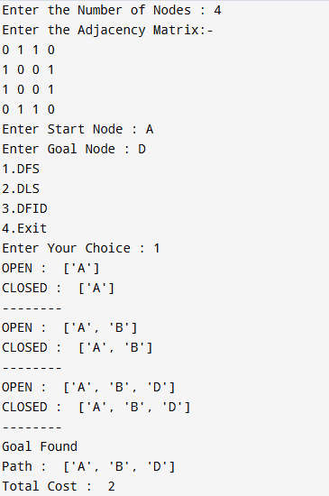
DFS
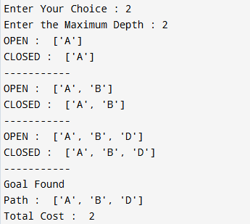
DLS

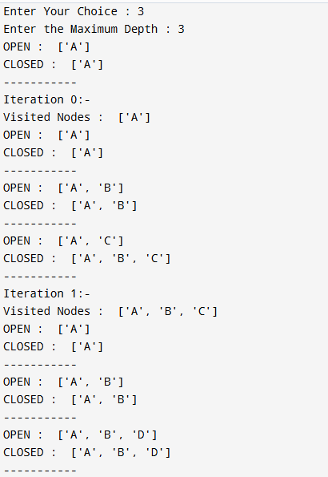
DFID

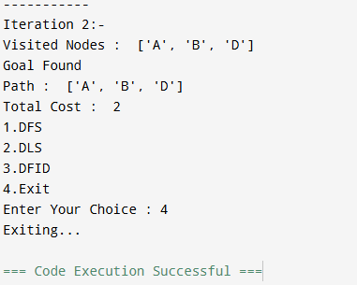

References
- Artificial Intelligence by Peter, Russell Norvig.

